A free cellular model of dune dynamics: Application to El Fangar spit dune System (Ebro Delta, Spain)

Fernando Barrio-Parra1,*, Inmaculada Rodríguez-Santalla1

1 Área de Geología, Dpto. de Biología y Geología, ESCET, Universidad Rey Juan Carlos, C/Tulipán s/n, 28933 Móstoles, Madrid, Spain

* Corresponding author. Tel.: +34 914888305; fax: +34 916647490. E-mail address [fernando.barrio@urjc.es](mailto:fernando.barrio@urjc.es)

**INSTRUCTION GUIDE**

# List of files in Computer code.zip

* Code.R: This is the R script. You can open it using the R software (downloadable form <http://cran.r-project.org/>) or RStudio (<http://www.rstudio.com/>). We recommend the use of RStudio because it is easier to distinguish the instructions from the sentences.
* WindData.txt: A txt file with the wind data employed in the paper.
* 20120415ascii.txt: A txt file containing a matrix with the initial dune.
* 20120418ascii.txt: A txt file containing a matrix with the initial dune.

The files with the Dune data comes from ASCII matrix files derived of ArcGIS raster files. The headers in these txt files had been removed.

# Installation

The R code needs of previous installation of R or RStudio. Instructions for these software installations can be found in its respective web pages.

The code can be loaded into the RStudio clicking on File🡪 Open File, and browsing to the file Code.R.

# Running the model

* When you open the Code.R file in RStudio, you will see the model script. Each line is explained and ordered under a title. The user should go step by step by the sentences reading its instructions, filling the data when requested, and running the lines or selections (Ctrl+Enter or clicking on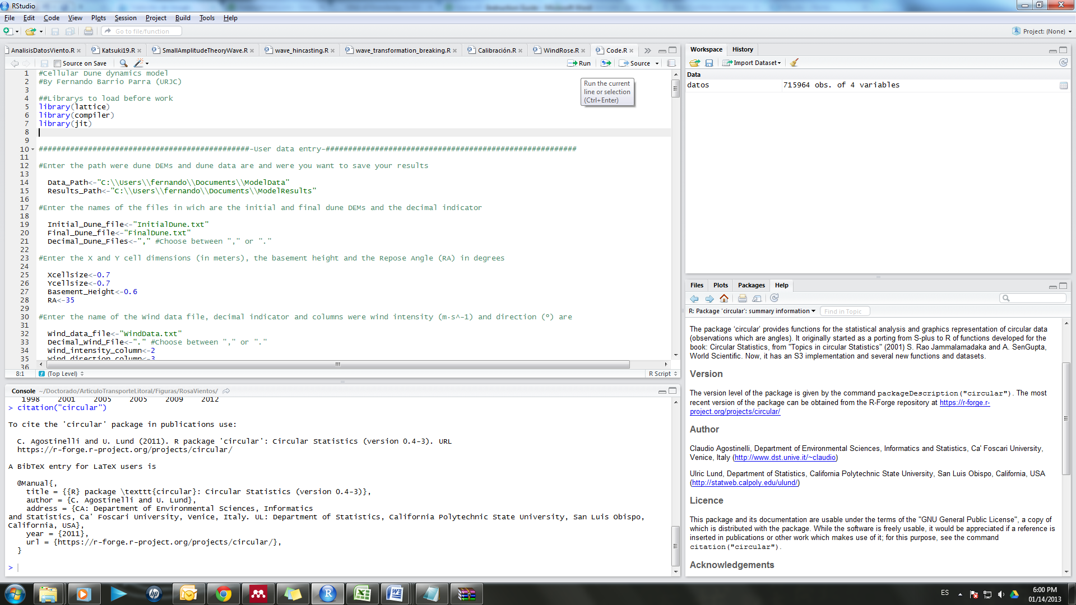). The code is ordered under these titles:
  1. A list of R library to be loaded before start. You have to install the Packages the first time you work in R. It can be done by clicking on Install Packages and searching for the lattice library.
  2. User data entry: In this section, the user can enter the model initial information, working path, parameter lists, etc.
  3. Data Preprocesing: Here we have sentences for DEM and wind data preprocessing.
  4. Auxiliary variables definition: In this piece of code, we define the variables that are going to be used in the algorithm. The definition is accompanied by a brief description.
  5. Slope, Aspect and hillshade application to the initial condition. In this piece of code we estimate the initial condition to enter in the main loop.
  6. MODEL: Here we have the model steps:
     + The definition of the Erosion and Saltation functions
     + The Saltation Algorithm
     + The Avalanche Algorithm
     + The algorithm to estimate Slope, Aspect and hillshade to each time step.
     + The error estimation
     + The simulation saving. The model saves its results into a .RData file, and a .gif animation with the name of the simulation number.
     + The result post-processing. Here we can plot the dune estate at each time step varying the third dimension of the DEM array.
* The code can be edited by the user, so we advise to work on a copy of the original code for avoiding non-desired modifications.
* The model is intended to its free use, improve and develop so feel free of improve or adapt to your needs all the pieces of code that you need.
* For a large time steps series the model will take several hours to run.
* The Vout and Vin objets will store the volume of sand that leaves the system, and that enters the system respectively.
* If you desire to open a simulation result, you can open the file .RData by clicking in, under the workspace menu.